[**ENGR100 Project – Tracking System for Solar Panels**](https://app.box.com/s/2ix3rc4cw3q34h5ash3royglwe2ofhdg)

**Part 1: Design and construct a simple low cost single-pole or dual-pole tracking system for one 100 Watt Renogy solar panel. Your goal is to design a product which will yield the greatest net gain in output power per $ spent. Assume the panel will be used on flat unobstructed ground in Irvine, CA. Maximum budget per team is ~ $300 (or per instructor).**

**Part 2 (Optional): For a 8’ x 8’ flat and unobstructed section of ground space in Irvine, CA, perform a study which determines the usefulness of a fixed, single-pole, and double-pole tracking system for 500 Watts solar panels. The solar panel array will consist of five Renogy (47” x 21”) 100 Watt units. The study should indicate whether any system has an advantage over the other two in terms of cost, net power generation. A ranking of each system should be performed based on a net power output per $ basis as well as the total net power over one day based on the net land (X-Y footprint) used within the 8’ x 8’ section. Any layout or configuration is acceptable within the 8’ x 8’ space within a maximum height of 5’.**

**Help:**

[Circuit Concept](http://projects-circuits.com/solar-tracker-azimuth-altitude-dual-axis-solar-tracking-system/)

[Sample Project](http://www.juliantrubin.com/encyclopedia/renewable_energy/solar_tracker.html)

[Simple calculator – optimal direction for fixed panel](http://energyworksus.com/solar_installation_position.html)

[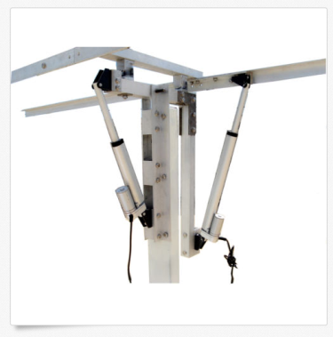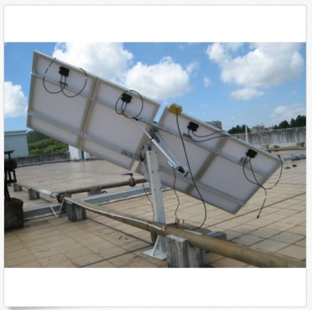](http://energyworksus.com/solar_installation_position.html)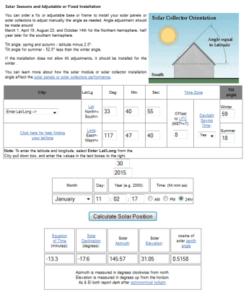

[Solar Tracking Overview](http://www.solar-tracking.com/)

[Tracking Systems](http://www.renewableenergyworld.com/rea/news/article/2013/06/on-track-to-succeed-with-solar-tracking-systems)

[DIY](http://livingonsolar.com/solar-tracking.html)

**Products**

[Version A](http://www.ebay.com/itm/Complete-Kit-sunlight-track-Single-Axis-solar-tracker-Linear-actuator-electronic-/390583381252?pt=LH_DefaultDomain_0&hash=item5af0956d04)

[Version B](http://www.ebay.com/itm/400W-WATT-Watts-W-solar-Complete-Tracking-system-Dual-axis-with-mounting-kits/351296914105?_trksid=p2047675.c100005.m1851&_trkparms=aid%3D222007%26algo%3DSIC.MBE%26ao%3D1%26asc%3D28808%26meid%3D4d16c856535d4f6ca6a6181835f187f2%26pid%3D100005%26rk%3D4%26rkt%3D6%26sd%3D351296932703&rt=nc)

**CAD**

[SketchUp](http://www.sketchup.com/download)

[Skelion](http://www.skelion.com/)